UCD Pool & Snooker Club

Club Report

2009-2010

By

Steven O'Reilly - Club President



It was another eventful year for the UCD Pool & Snooker Club this year with results again more promising than seasons' past.

In terms of on campus Pool Tournaments. There were 6 ranking tournaments in total with a number of other of non-ranking events taking place.

These non-ranking events included the:

- '9 Ball Tournament ' in The Palace, won by Steven O'Reilly.
- 'Valentine's mixed doubles' won by Lorcan & Sinead.
- 'UCD One Frame Shoot Out' won by Peter Lynam.

Shown below is the top 32 ranked players at the end of the 2009/10 season.

Name | Ranking Points | Frame Difference | Postion
Kavanagh, Lorcan | 27 | 45 | 1
O'Reilly, Steve | 25 | 30 | 2
Mobasser, Oliver | 24 | 38 | 3
Johnston, Paul | 23 | 31 | 4
Sheehy, Ger | 23 | 31 | 4
Doogue, William | 21 | 30 | 6
Lynam, Patrick | 21 | 29 | 7
King, Darragh | 20 | 25 | 8
McLean, Brian | 19 | 23 | 9
McAweeney, Seamas | 18 | 26 | 10
Doran, James | 18 | 24 | 11
Lynam, Peter | 15 | 19 | 12
Thompson, Joe | 15 | 18 | 13
Kavanagh, Dean | 15 | 16 | 14
Delahunty, Eoin | 14 | 15 | 15
Brady, Laurence | 11 | 14 | 16
Conaty, Noel | 11 | 12 | 17
Good, Jack | 11 | 11 | 18
Murphy, Stephen | 10 | 10 | 19
Toner, JP | 8 | 9 | 20
Beirne, Kevin | 8 | 8 | 21
Carey, Brian | 8 | 8 | 21
McGuire, Padraig | 7 | 9 | 23
Aherne, Bernard | 7 | 8 | 24
Pillay, Steven | 6 | 9 | 25
Kelly, John | 6 | 5 | 26
Morris, Michael | 6 | 5 | 26
Meaney, Kevin | 5 | 9 | 28
Murphy, Maurice | 5 | 5 | 29
Doyle, Ronan | 5 | 4 | 30
McDermott, Brian | 5 | 3 | 31
Togher, Stephen | 4 | 6 | 32
HESPC Pool Intervarsity’s

Dundalk, Co. Louth 5th - 7th February 2010

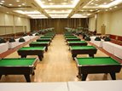
This year's HESPC All Ireland Intervarsity Pool Championships had a new venue to act as host for the competition that saw 41 teams descend on the Fairway's Hotel, Dundalk, Co. Louth to compete for the title.
New Venue Fairway's Hotel

Team Event

UCD sent just 2 teams this year due to financial restraints, of which, both made it to the last 16 in the tournament. The UCD ‘A’ team came second in their group with convincing wins over CIT ‘A’ (9-1), UUJ 'C' (9-1) and a narrow win that meant they qualified for the knock-out stages of the tournament over Queens 'C' coming from 4-0 down to win 6-4. Losses were recorded against DKIT 'B' (4-6) and UUC 'B' (4-6).

The ‘B’ team recorded excellent wins over GCD 'A' (8-2), UUC 'C' (6-4), UL 'B' (7-3) with a draw against UCC 'A' (5-5), losing only to NUIG ‘A’. Despite this and as the standard was quite high in the group results favoured UCD ‘B’ and they also finished 2nd in their group.

In the end UCD ‘A’ lost out 4-6 to NCI 'A' in a very tense final frame. The UCD ‘B’ team were defeated by an excellent DCU 'A' team in yet another decider.

Dundalk IT "A" (Defending Champions) finished the weekend as the runners-up eventually losing (5-8) to Queens 'A' in a repeat of the 2008/2009 final proving that Dundalk 'IT 'A' were worthy champions and quenched any doubts that any opponents had from the year previous.
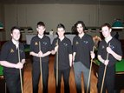
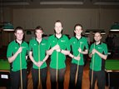

DKIT 'A'- Runners' up
Queens 'A' - Winners

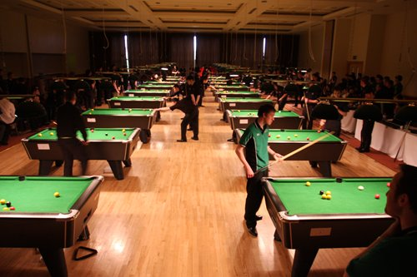

Teams in action

Singles Event

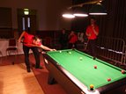
As regards the singles event of the weekend, it was Steven O'Reilly of the UCD ‘A’ team that managed to get the furthest of all 11 UCD players reaching the last 16 of 220 players losing to 2008/2009 winner Dave Columb.
Dave Column 2009
Individual Winner

UCD's William Doogue was unlucky in not reaching the last 16 (as he did in the 2008/2009 season) losing 3-2 in his last 32 match.
This year, the final was between defending Champion, Stephen Dempsey (NUIG) (2007 European Men’s Pool Champion) and Chris Beattie (BMet) with Beattie easing past Demsey 4-0 in a very top quality final good enough to be seen at the top level of the game.

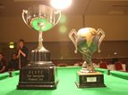

UCD 'A' player Steven O’Reilly (UCD Pool & Snooker Club President) secured a place on the College Irish Team for a 3rd time in 4 years. He will represent Ireland in the Home Nations Pool which will be held in Cardiff, Wales in April of 2010 alongside 5 other players from the event.

Pool Leagues

The Pool Leagues that Club President Steven O'Reilly helped set up in 2008-2009 season were even better this year.

Unfortunately due to a very tough group, the UCD 'B' team were up against it and did not qualify for the League finals in Belfast. There were pitted against a very strong DIT 'A' team which were League Title holders and defending Champions. Also in their group were an improved NCI 'A' Team and the new Dublin Business School Team. UCD 'B' finished bottom of the group only recording 1 out of 6 wins.

On the up side, UCD 'A' did qualify for the League Finals despite having another tough group to contend with. The teams in the group included Intervarsity Champions Dundalk IT 'A', Trinity 'A' and a very good DCU 'B' team. With 2 substantial wins against the DCU 'B' side and 2 narrow losses to the Intervarsity Champions it was the 2 results home and away to Trinity 'A' that were to matter for qualification. Thankfully, after a narrow win away to Trinity early in the group stage 10-8, the same result was recorded on the return visit from the rivals in a final frame decider.

CUSAI - HESPC Pool League Finals

Lavery's, Belfast, 19th March 2010

And so it was to the pool league finals, which was held in Lavery's pool hall in Belfast. 8 teams battled it out for the title of League champion 2009-2010.
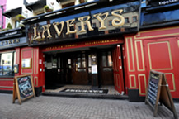
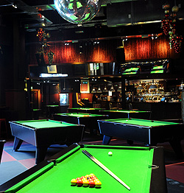
The fantastic venue @ Lavery's

UCD 'A' had DCU 'A' in the first of the quarter final matches and it looked like the DCU team were going to run away with it from the beginning winning both of the first 2, 5 frame sessions. However a run of solid pool playing in the 3rd session saw the UCD boys take the lead going into the final of the 4 sessions. The match eventually evened itself out at 8 a piece meaning that both teams needed both of the remaining frames to win the match. Unfortunately with 2 bouts of bad luck, UCD lost both of the frames handing a semi final place to the DCU boys 10-8 who eventually won the League Finals with ease beating DIT 'A' 10-4 in the final after the tense match against UCD.

HESPC Snooker Intervarsity's

Caesar’s Palace, Salthill, 5-6 December 2009

The venue for the Snooker Intervarsity's changes this year meaning the 2 teams representing UCD had to travel to Salthill, Galway. The fantastic venue was home for 13 teams this year, of which, 2 represented UCD.
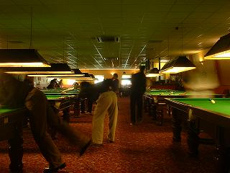

Venue: Ceasar's Palace, Salthill, Galway

The 'B' team were drawn against Intervarsity defending champions of 3 years, NUIM 'A' and also an ever strong UUC 'A'. NUIM 'A' really showed the inexperienced UCD 'B' team who was boss by defeating the underdogs by a perfect score 10-0. Subsequently NUIM 'A' convincingly beat the northern boys UUC 'A' by a 7-3 score line. All that UCD 'B' had to do was secure a victory over the northern lads to go through to the knock-out stages of the event as the top 2 of 3 in the group were to progress. This looked very unlikely as the UCD boys went 4-0 down with their backs against the wall. Amazingly three 2-0 wins clocked up meant the UCD 'B' team took all remaining 6 frames to win 6-4 and progress to the knock-outs. A confidence boosting win for the lads.

UCD 'A' had to contend with Queens QUB 'B' team and the NUIM 'B' team. Not as tough as fellow 'B' team mates group but none the less they still had it all to do. A great 8-2 victory for UCD 'A' over the NUIM 'B' team left them with high hopes, however losing the final 2 frames of the match that was tied 4-4 with QUB 'B' meant that although UCD 'A' had qualified, they were to be up against a top seed in the quarter finals.

As it happened UCD 'A' were draw against the '3 in a row' Intervarsity Champions in the Quarter finals and in a race to 6 frames UCD could only hold them to a 6-1 score line which meant it was the end of the tournament for the boys. UCD 'B' were to record a similar loss in the quarters losing 6-2 to QUB 'B', the team that UCD 'A' couldn't get the better of in their group.

As for the Individuals it was Johnny Williams defending champion of 2 years that stormed to yet another individual final again, losing just 1 frame on his way to victory beating QUB 'A' veteran Gary Menary ex Intervarsity Champion.

UCD's Paul Johnston impressed this year making his way to the last 16 only losing out to eventual quarter finalist UUJ's Conor McDonnell. UCD's Steven O'Reilly played well enough again to reach the quarter finals, this time losing for the first time to QUB 'A' team player and old rival Paul McKay 2-0.

Steven will, for the second year in a row be made team organiser and team captain for the Snooker Home Nations. He will represent Ireland at the event which will be held in Belfast in April of this year.

Committee Positions 2010-2011

For next year's committee, Steven O'Reilly will continue as President of the Club and Junior Treasurer, while also taking on the role of Children's Officer.

Dr. Henry Doran has agreed to stay on as Senior Treasurer.

Lorcan Kavanagh has been voted Club Captain while also keeping the role of PR Officer.

William Doogue is again Safety Officer for the club.

Finally, Ger Sheehy is the New Members Officer.

Accounts 2009-2010

Opening Balance 2009/2010 (€) |  | € 11.75
Income
Subscriptions |  | 1,230.00
Entry Fees |  | 1,095.00
Players Contributions |  | 1,047.00
Grant |  | 3,000.00
Total Income |  | 6,383.75
Expenditure
Pool League (Entry Fees + Home Matches Costs) |  | 270.00
League Finals Accommodation |  | 150.00
Entry Fees (Intervarsity's only) |  | 404.00
Euro Coins (Tournaments) |  | 778.00
Club T-Shirts |  | 575.00
Prize Money |  | 860.00
The Palace Pool Hall |  | 250.00
Dundalk Memorial Tournament |  | 35.00
Snooker Intervarsity's Accommodation |  | 750.00
Pool Intervarsity's Accommodation |  | 1,000.00
Travel Expenses |  | 240.00
Snooker Practice |  | 824.00
Pool Practice |  | 80.00
Posters |  | 80.00
Stationary |  | 40.00
Government Stamp Duty |  | 7.50
Phone |  | 20.00
Code of Ethics Course |  | 15.00
Total Expenditure |  | € 6,378.50
Closing Balance 2009/2010 |  | 5.25

